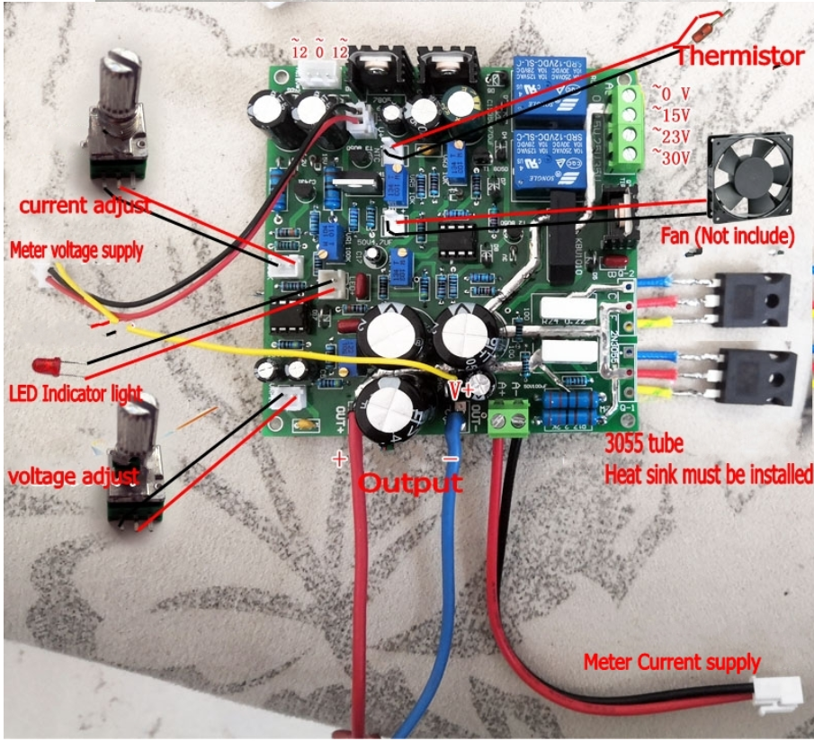Note the 2-wire V&A adlustments.

The 5-volt utility is rotated 90-degrees.

The 7812 and 7912 regulators for the ulility system are not present(?).

The more common V&A meter is powered from the 5-volt utility supply and V+ sense (yellow) is connected to V+ connection near the output (Blue wire).

**This is not the board that I received, but close!**